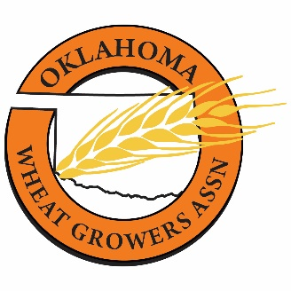

**Annual Meeting**

**Tuesday, August 13, 2024**

**Autry Technology Center – 1201 W. Willow Rd – Enid, OK**

10:00 a.m. – 11:00 a.m.               **Exhibitor Setup**

10:30 a.m. – 11:30 a.m. **Available tour for Chisholm Trail Milling, Autry Tech**

11:00 a.m.            **Member check-in begins & exhibitor visits**

11:30 a.m. **Lunch available**

12:00 p.m. – 12:15 p.m. ***Welcome***

Dr. Marcie Mack, Executive Director, Enid Regional

Development Alliance

12:15 p.m. – 12:35 p.m.               ***Wheat Taps Program at OSU***

Dr. Amanda De Oliveira Silva, Assistant Professor, Small Grains Extension Specialist, Oklahoma State University

12:35 p.m. – 12:50 p.m. ***Oklahoma Ag Leadership Program***

Edmond Bonjour, Director, Oklahoma Agricultural Leadership Program

12:50 p.m. – 1:50 p.m. ***Best Management Practices for Insecticide and Fungicide Seed Treatments on Winter Wheat***

Josh Bushong, Area Extension Agronomist, OSU

1:50 p.m. – 2:10 p.m. **BREAK** (Networking & Exhibitor Visits)

2:10 p.m. – 2:40 p.m.                   ***Legislative Update***

Jeff Hickman, OWGA Executive Director

Lori Peterson, OWGA General Counsel

Jami Longacre, OWGA Government Affairs Director

2:40 p.m. – 3:40 p.m.  ***OSU Wheat Breeding – 2024***

Dr. Brett Carver, OSU Regents Plant & Soil Science Professor and Wheat Genetics Chair

3:40 p.m. – 4:00 p.m. **BREAK** (Networking & Exhibitor Visits)

4:00 p.m. – 4:15 p.m. ***Where the Wheat Check Off Dollars Go***

Mike Schulte, Executive Director, Oklahoma Wheat Commission

4:15 p.m. – 4:30 p.m. ***NAWG President Update***

Keeff Felty

4:30 p.m. – 5:00 p.m.                    **Annual Meeting & Awards**

5:30 p.m. – 6:00 p.m.                    ***OWGA Board of Directors Meeting***