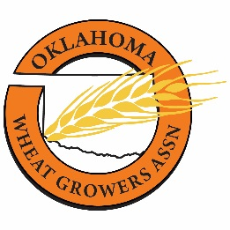

**Oklahoma Wheat Growers Association**

2309 N 10th Street, Suite E

Enid OK 73701

Phone: 580/233-9516

Fax: 580/237-2131

**Board of Directors’ Meeting**

**Wednesday, July 19, 2023**

**1:30 p.m.**

Oklahoma Wheat Commission

8820 Silver Hill Drive

Oklahoma City OK

Revised Agenda

**Call to Order.** Roll call and announcement of quorum.

**Invocation.**

**Minutes of Previous Meeting.** Approval minutes from April 6, 2023.

**Financials.** Approval of year-end financial statement (June 30, 2023).

**National Association of Wheat Growers MOA.** Discussion/Approval of Memorandum of Agreement with NAWG.

**Discussion of Annual Meeting.** August 30, 2023. Meridian Technology Center, Stillwater, OK**.** Discussion of Awards: Mr. Wheat, Wheat Promotor of the Year, Service to the Industry

**Discussion of Oklahoma Wheat Commission MOA.** Discussion/Approval of Memorandum of Agreement with OWC.

**Adjournment.**

**Next Board Meeting**

Wednesday, August 30, 2023

Approximately 5:15 p.m.

Smokin’Joe’s Stilly

616 South Range Road, Stillwater OK